**Research Proposal**

**Modelling Full-scale High Recovery Wastewater Effluent Reverse Osmosis: Investigating Key Transport Properties**

**Abstract**

Reverse Osmosis (RO) has the potential to treat tertiary wastewater effluents as a polishing step, ensuring potable water integrity and allowing for unrestricted agricultural applications. Despite the significant advancements of RO in water treatment, efficiency in terms of energy consumption remains a bottleneck. In this study, we develop a 5-stage high-recovery wastewater effluent RO simulation with an ultra-high recovery of 98%. Our primary objective is to assess the pivotal influence of membrane permeability and recovery rate on the optimization of energy utilization in effluent RO processes. The intricate relationship between membrane permeability and specific energy consumption is elucidated by enhancing the water permeability of low-pressure commercially available membranes by increments of 50% and 100% and quantifying the resultant impact on the latter.

Modelling Full-scale High Recovery RO Desalination; Investigating Key Transport Properties

Several research efforts have shown the need for increased water permeability using novel membrane fabrication techniques such as aquaporins, graphene oxide with exceptional water permeability features. The specific energy consumption estimates for seawater and brackish water reverse osmosis have also been reported with results showing the preference for an increase in membrane selectivity over water permeability. Effluent reverse osmosis has scarcely been reported in the literature, and the only study so far illustrates the impact of alternating membrane and module specifications namely, membrane length, membrane width and feed channel height on the total overall energy consumption, chlorophenol rejection and total recovery rate1. This study uses a numerical modelling approach to investigate the specific energy consumption of a 5-stage effluent reverse osmosis at ultra-high recovery rate of 98%.

1. How much energy can be saved by increasing the membrane water permeability, and at what threshold does this effect become insignificant?

* Increase current water permeability values by 50% and 100%. Do a comparative analysis.

1. Simulated Batch RO system at recovery stages higher than 75% due to the high concentration of the brine, causing a sharp decline in the flux. Done

* Compare the osmotic pressure vs hydraulic pressures of the conventional multistage RO process with Batch multistage RO process at high recovery ratios.
* Compare the SEC for the two processes. Typically, a Batch and Semi-Batch process should reduce the energy consumption due to the minimization of the brine concentration by the fresh incoming feed.

1. Increasing the rejection of the model micropollutant resulted in a decrease in the hydraulic permeability. (Permeability selected trade-off)

Rejection was increased from 30%, 50%, 60%, 90%

1. Get the total flow rate of wastewater treatment plant and calculate the polishing cost.

First Case

The rejection of the model micropollutant, acetaminophen (ACN) was 30% in a solution containing three micropollutants carbamazepine (CBZ), bisphenol (BPA), and acetaminophen (ACN). The model solute permeability and hydraulic permeability were evaluated to be 40.5 Lm-2h-1, and 1.8 Lm-2h-1Bar-1 respectively. Modelling the specific energy consumption (SEC) for the multistage RO process, with total SEC of 0.33025 kwh/m3, the first stage, second stage, third stage, fourth stage and fifth stage yielded 0.3213 kwh/m3, 0.006251 kwh/m3, 0.001417 kwh/m3, 0.001106 kwh/m3 and 0.00017 kwh/m3 respectively, for a 98% recovery. The first stage accounted for 97.3% of the total SEC where 50% of the entire volume of water is recovered. The third and fourth stage operated at a batch process to minimize the brine concentration and operate optimal at an average flux of 19 Lm-2h-1.

Increasing the micropollutant rejection to 50%, simulated as 17.36 Lm-2h-1 caused a decrease in the water permeability to 1.61 Lm-2h-1Bar-1, typifying the permeability-selectivity trade-off, while the total SEC summed up to 0.3682 kwh/m3. A further increase in the solute rejection to 99% for an ideal membrane, simulated with solute permeability of 0.175 Lm-2h-1 resulted in a reduction in the water permeability to 1.08 Lm-2h-1 Bar-1 with total SEC at 0.5863 kwh/m3.

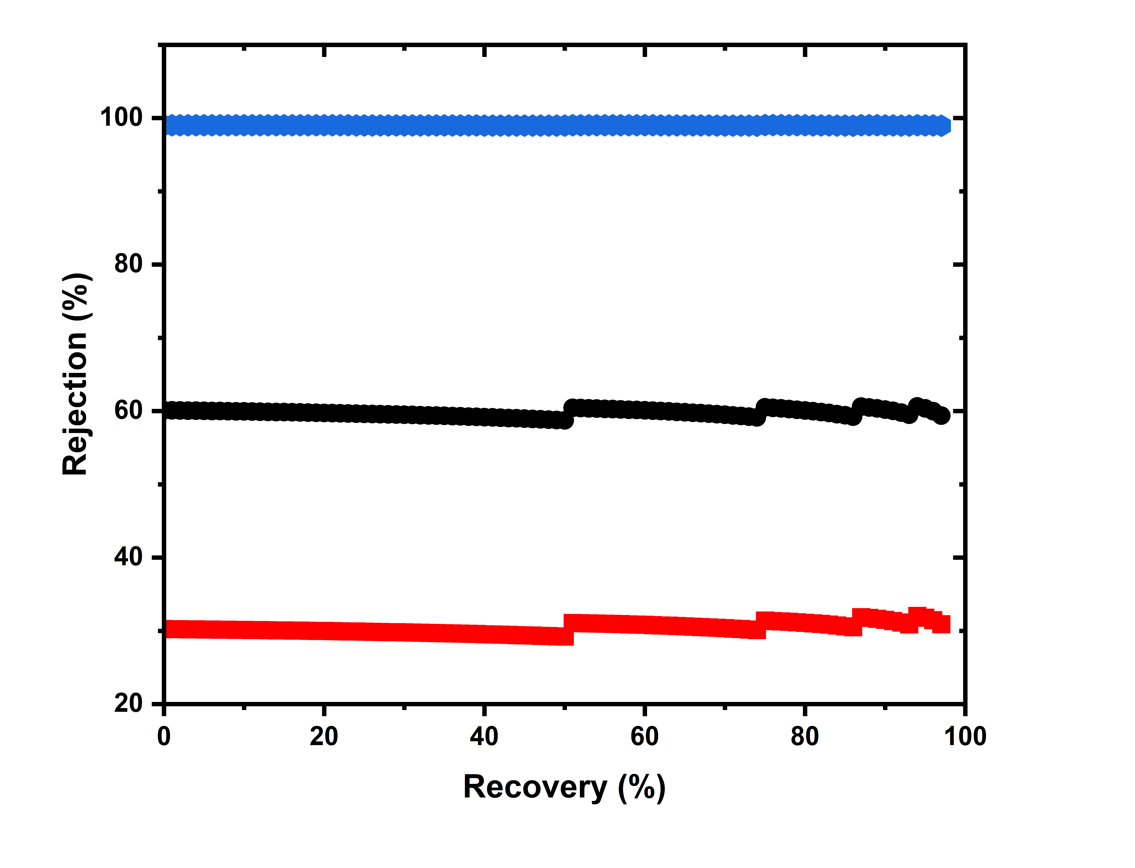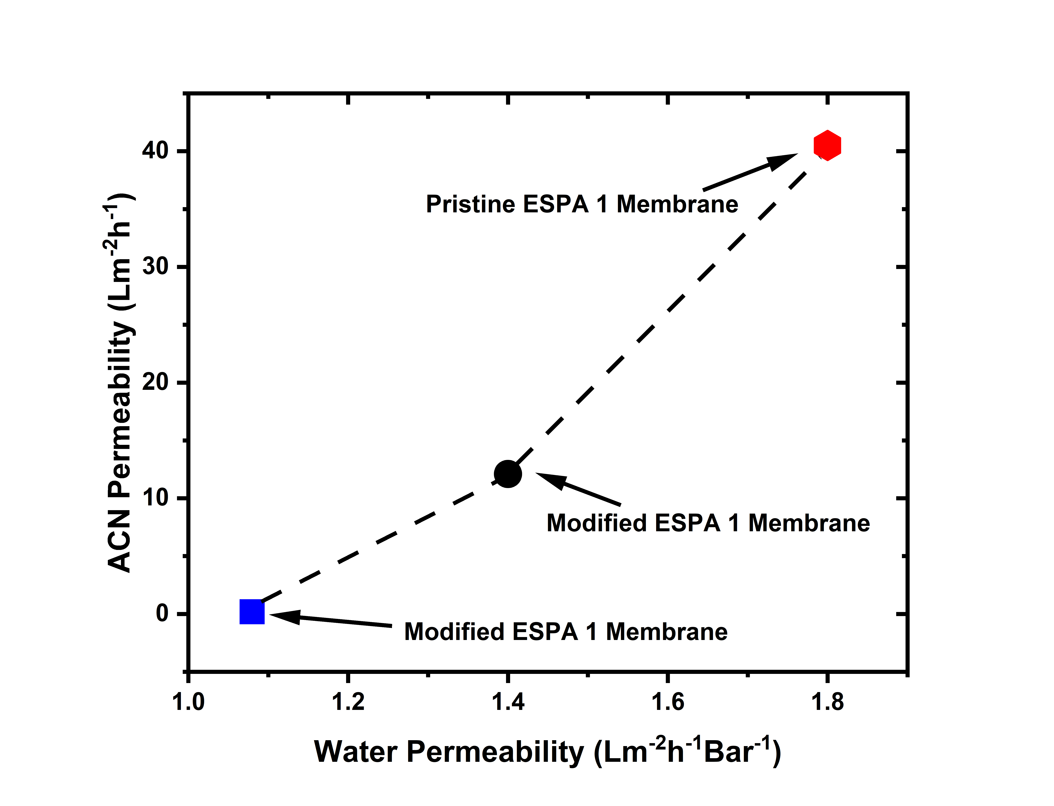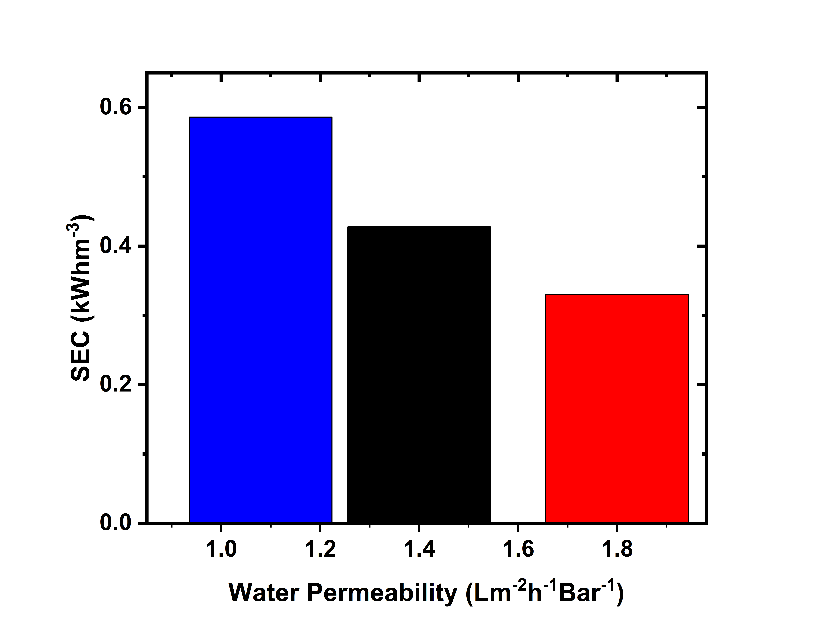

Fig 1: Rejection of modified and pristine ESPA 1 element at 98% recovery. Fig 1b depicts the permeability-selectivity trade-off.

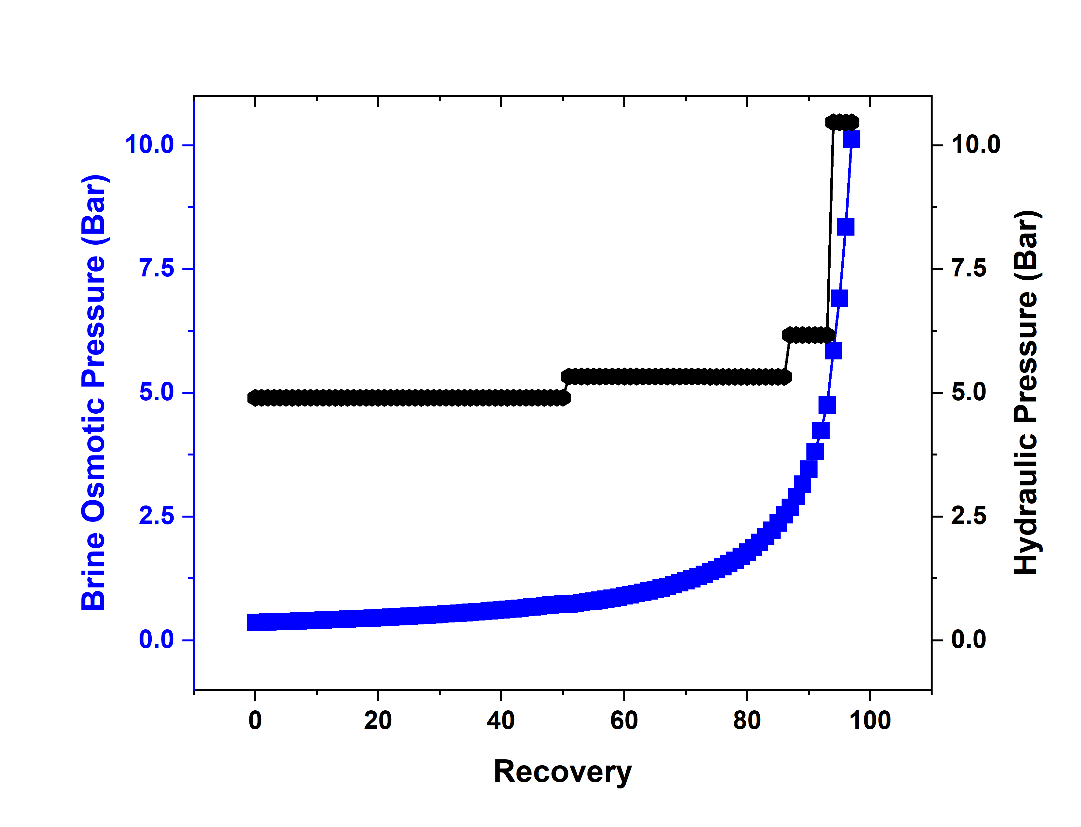

**Fig 3:** The minimum hydraulic pressure is the osmotic pressure of the brine exiting the pressure vessel. To achieve the desired average flux (19LMH) for each stage, hydraulic overpressure is needed, this leads to irreversible losses. Multi-staging of RO processes helps to reduce these losses thereby improving energy efficiency.

Second Case

The water permeabilities were increased by 50% for the commercial membranes to simulate filtration with hypothesized membranes with greater water permeance.

Third Case

The water permeabilities were increased by 100% for the commercial membranes to simulate filtration with hypothesized membranes with greater water permeance.

**SPECIFIC ENERGY CONSUMPTION**

Few examples of membranes

Graph of

Comparing Rejections